YOUNGGUN KIM

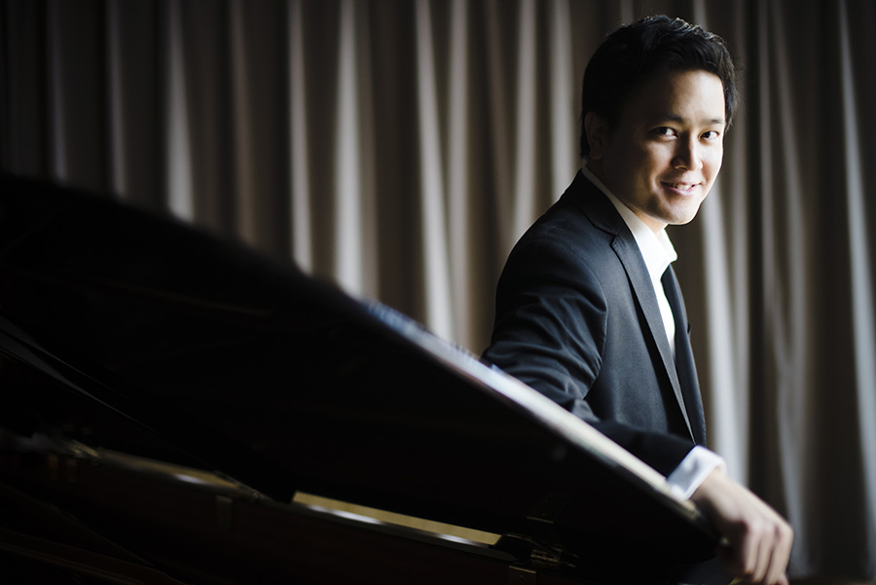

Younggun Kim is a pianist known for his blazing technical capacity and a lush sound supported by a natural phrasing sense (Timothy Gilligan, New York Concert Review), who has performed across North America and Europe. He is active as concerto soloist, recitalist, and chamber musician, and he teaches at the University of Toronto. Younggun has also been closely involved with the Health Arts Society (Concerts in Care) since 2011, playing in their concert series for those who may find it difficult to visit conventional venues.

His recent performances highlights include a solo appearance with Toronto Korean-Canadian Choir/Orchestra playing Beethoven’s Choral Fantasy, solo recital as a part of Faculty Artist Series at Queen’s University, a duo recital with Sophie Dervaux who is a member of the Vienna Philharmonic, an appearance with the esteemed Isabel Quartet performing Robert Schumann’s Quintet, a concerto performance with Niagara Symphony as well as recital engagements in Seoul, Korea.

Younggun is the winner of various prizes including San Antonio International Competition, Concours International de Piano Francis Poulenc, and Doctor of Musical Arts Recital Competition at the University of Toronto. Upon completion of the doctoral degree, Younggun was chosen as the recipient of the Tecumseh Sherman Rogers Graduating Award, which is the largest award offered by the Faculty of Music.

He is a Toronto-based Canadian from South Korea. After changing his career path in his early twenties from French literature to music, Younggun finished his undergraduate degree at the Glenn Gould School of the Royal Conservatory of Music, received a Master’s Degree at Peabody Institute of Johns Hopkins University, and the Doctor of Musical Arts Degree at the University of Toronto. He studied with renowned artists such as Boris Slutsky and the late Marietta Orlov.

